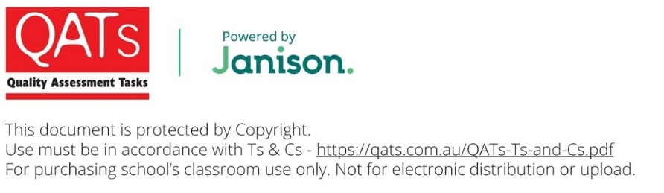
NAME: ____________________________
VCE®SPECIALIST MATHEMATICS
Units 3 & 4 Practice Written Examination 1
Reading time: 15 minutes
Writing time: 1 hour
QUESTION AND ANSWER BOOK
Structure of book
Number of  questions | Number of questions  to be answered | Number of  marks
10 | 10 | 40

- Students are permitted to bring into the examination room: pens, pencils, highlighters, erasers, sharpeners, rulers.
- Students are NOT permitted to bring into the examination room: any technology (calculators or software), notes of any kind, blank sheets of paper and/or correction fluid/tape.
Materials supplied
- Question and Answer Booklet of 14 pages.
- Formula Sheet.
- Working space is provided throughout the Question and Answer Booklet.
Instructions
- Write your student name in the space provided above on this page.
- Unless otherwise indicated, the diagrams in this book are not drawn to scale.
- All written responses must be in English.
Students are NOT permitted to bring mobile phones and/or any other unauthorised electronic devices into the examination room.

Instructions
Answer all questions in the space provided.
Unless otherwise specified, an exact answer is required to a question.
In questions where more than one mark is available, appropriate working must be shown.
Unless otherwise indicated, the diagrams in this book are not drawn to scale.
Take the acceleration due to gravity to have magnitude g m where .
Question 1 (5 marks)
Consider the function with rule where k is a real constant.
- Find the value(s) of k for which the graph of does not intersect its asymptote. 2 marks

- Sketch the graph of for on the axes below. Label any asymptotes with their equation and any turning points and intersection with asymptotes with their coordinates. 3 marks
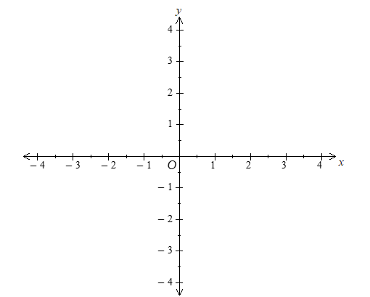
Working space

Question 2 (4 marks)
Solve where

Question 3 (4 marks)
A particle with an initial velocity of 1 ms⁻¹ moves in a straight line. When the particle is x m from its starting point its velocity, v ms⁻¹, after t seconds is given by
, where .
Find the position of the particle when .

Question 4 (3 marks)
A particle moves in a straight line such that after t seconds its displacement x meters from a fixed origin O is given by .
Find the acceleration of the particle when and .

Question 5 (3 marks)
Evaluate

Question 6 (4 marks)
The Gratuitous Apple Farm grows apples. It is known that the standard deviation of the mass of the apples is 5 grams. A random sample of 64 apples is used to calculate an approximate C% confidence interval for the mean mass, measured in grams, of all apples grown on the farm.
The confidence interval was found to be (201.2, 202.6).
- where Z is the standard normal random variable.
Find the value of k. 1 mark

A larger sample of apples is selected, with a sample size four times the original sample. The sample mean is found to be the same.
- State the approximate C% confidence interval for the mean mass, measured in grams, of all apples grown on the farm that would be calculated using this sample. Give all values correct to one decimal place. 1 mark

The Gratuitous Apple Farm also grows a small crop of genetically modified apples. The mass of these apples is normally distributed with a mean of 144 grams and a standard deviation of 8 grams.
- Two genetically modified apples are chosen at random and compared to a third genetically modified apple. Find the probability that the combined mass of the two chosen apples is less than of the mass of the third apple. Use and give your answer correct to three decimal places. 2 marks

Question 7 (4 marks)
The curve defined by the parametric equations
, , where
is rotated about the y-axis.
Find the area of the surface generated.

Question 8 (3 marks)
Use mathematical induction to prove that for ,
for all sets of differentiable functions , , , .

Question 9 (5 marks)
Consider the following planes:
:
:
- Find the value(s) of m that will make and perpendicular to each other. 2 marks

- Let .
Find a vector perpendicular to and the line 3 marks

Question 10 (5 marks)
The velocity vector of a particle at time t seconds is given by
The particle is initially at the point (0, 1, 0).
- Find the position vector of the particle after t seconds. 2 marks

The position vector of a second particle at time t seconds is given by
- Find the times at which the two particles are moving in the same direction. 3 marks

END OF EXAMINATION
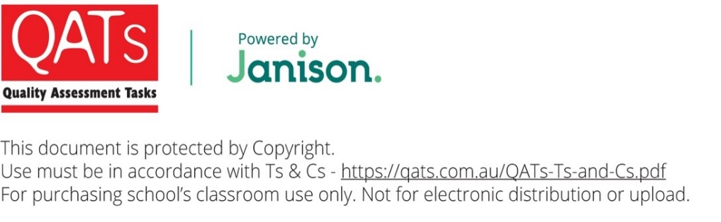
VCE® Specialist Mathematics
Practice Written Examination 1
ADVICE FOR TEACHERS
Teachers should provide students with a copy of the VCAA formula sheet.
The VCAA formula sheet can be downloaded and printed from
https://www.vcaa.vic.edu.au/assessment/vce-assessment/past-examinations/Pages/Specialist-Mathematics.aspx

IMPORTANT SECURITY ADVICE FOR EXAMINATION TASKS
By ordering and using QATs materials from Janison you are agreeing to the Terms and Conditions of sale, found at qats.com.au/QATs-Ts-and-Cs
Storage
This resource is protected by Copyright and sold on the condition that it is not placed on any school network, student management system or social media site (such as Facebook, Google Drive, OneDrive, etc.) at any time. It should be stored on a local device drive of the teacher who made the purchase.
Purchaser Use
This resource is for use in the purchasing school or institution only. STRICTLY NOT FOR PRIVATE TUTOR USE. You may not make copies, sell, lend, borrow, upload, or distribute any of the contents within the QATS product or produce, transmit, communicate, adapt, distribute, license, sell, modify, publish, or otherwise use, any part of the QATs product without our permission or as permitted under our Terms and Conditions.
Embargo
Students must not take their Examination Assessment Tasks home/out of the classroom until the end of the embargoed period. This is to ensure the integrity of the task. In NSW, this period is mandated by QATs. In VIC, QLD and SA this period may be determined by individual schools based on specific school requirements. Teachers may go through papers and results with students in class during this period; however, papers must be collected and kept by the teacher at the end of the lesson (or similar). When the embargoed period has ended, assessments may be permanently returned to students.
Compliance and Task Editing
This task has been developed to be compliant with VCAA assessment requirements, however, QATs does not guarantee or warrant compliance.
It may be necessary to edit or change this task for security or compliance purposes. Permission is provided to do this for internal school purposes only. If so, care should be taken to maintain the quality of the material concerning its design and layout, including such elements as marking schemes, pagination, cross-referencing, and so on. QATs assumes no responsibility for the integrity of the task once it is changed. If you edit this task you must:
- Remove the QATs and Janison logos and all other references to QATs and Janison.
- Select and copy ‘Task’ pages ONLY into a new document. These are the only pages students will require to complete their assessment. Save with a school-/class-specific file/subject/outcome name. Do not use the QATs file code.
- Remove all footer information from all pages. The page 1 footer of QATs is usually set up differently from other pages. Insert your own footer information for your reference.
- Remove all QATs header references from all pages.
- Insert your school logo/identification on page 1 and other pages at your discretion.
Unless otherwise indicated and to the best of our knowledge, all copyright in the QATS product is owned by or licensed to Janison Solutions Pty Ltd (ABN 35 081 797 494) trading as QATS. If you reasonably believe that any content in our QATS product infringes on anyone’s intellectual property rights or is the owner of the copyright and would like to request removal of the content, please email qatsadmin@janison.com
Solution Pathway
Below are sample answers. Please consider the merit of alternative responses.
Specialist Mathematics Examination 1: Marking Scheme
Question 1
Part a.:
A function can intersect with either a horizontal asymptote or a diagonal (oblique, slant) asymptote:
Therefore
Diagonal asymptote: | 1 mark
Solve : .
By inspection there is no solution when
Answer: | 1 mark

Part b.:
Answer:
Shape:  Must have a y-intercept at | 1 mark
Turning point: | 1 mark
Diagonal asymptote:  Graph must be consistent with axes scale.  Intersection point: | 1 mark

Calculations:
- Diagonal asymptote: (from part a.).
- Intersection with asymptote:
Substitute into from part a.: .
- Approach towards diagonal asymptote:
(from part a.) as
therefore, the approach is from above.
(from part a.) as
therefore, the approach is from below.
The approach can also be deduced from the fact that the graph must intersect the diagonal asymptote.
- Turning point: Solve .
(by inspection).

Question 2
Substitute , :
(1)
Equate real parts of (1): (2)
Equate imaginary parts of (1):
therefore or
Case 1: .  Substitute into equation (2): | 1 mark
Case 1 (a):
( is rejected because )
Answer: | 1 mark
Case 1 (b):
( is rejected because ).
Answer: . | 1 mark
Case 2:  Substitute into equation (2) and simplify:  There is no real solution (proof is not required). | 1 mark
The fact that there is no real solution can be seen by inspecting the graphs of and and noting that the graphs do not intersect each other.

Question 3
1 mark
.
Substitute :
, where
1 mark
, where .
Substitute when : .
1 mark
Substitute :
Answer:  Accept | 1 mark
Question 4
The value of when and is required.
Use implicit differentiation:
Differentiate with respect to t:
Result of implicit differentiation: | 1 mark
Substitute and : .
Differentiate with respect to t:
Result of implicit differentiation:  . | 1 mark
Substitute and and :
Answer: m | 1 mark
Question 5
Use integration by parts to calculate :
1 mark
1 mark
Therefore:
Answer:  Accept | 1 mark

Question 6
Confidence interval endpoints of a C% confidence interval:
where is such that
Part a.:
Compare the endpoints of the given confidence interval (201.2, 202.6) with
It follows that:
Answer:  Accept 1.12 | 1 mark

Part b.:
Method 1:
Compare the endpoints of the given confidence interval (201.2, 202.6) with
It follows that:
Substitute , , and into
Method 2:
Let . Width of new confidence interval:
remains the same therefore the new confidence interval is
Answer: (201.55, 202.25) | 1 mark

Part c.:
Let X be the random variable “Mass of a genetically modified apple”.
X is normally distributed with a mean of 144 grams and a standard deviation of 8 grams.
is required
where , , are independent copies of X.
Let Y be the random variable . Then is required.
Note: Using the random variable is incorrect:
Y follows a normal distribution since , , are independent normal random variables.
Y ~ Normal | 1 mark:  Definition.  Distribution.  Probability.
therefore .
.
.  Answer: 0.023 | 1 mark:  Calculation of Z.  Answer.

Question 7
Substitute and :
1 mark

1 mark

Since for | 1 mark:  Justification for dropping modulus.  Integral.
Substitute :
.
Answer: square units. | 1 mark

Question 8
- Let be the conjecture  - Check :  LHSRHS  Therefore is true.  - Assume is true for some : | 1 mark:  Statement.  Base case.  Inductive hypothesis.

- Show that if is true then it follows that is true: | 1 mark:  Statement.  Recognition that  is a product of the two functions  and  .

Using the inductive hypothesis  Which is equivalent to true.  - Since is true and it follows that if is true then is true, it follows from the principle of mathematical induction that is true for . | 1 mark:  Use of inductive hypothesis.  .  Conclusion.

Question 9
Part a.:
:
:
and are perpendicular when :
1 mark
Answer: | 1 mark

Part b.:
:
Parametric equations of the line :
Vector in direction of the line (by inspection of the coefficients of t in the parametric equations):
1 mark:
Vector perpendicular to and :
1 mark

Answer: . | 1 mark

Question 10
Part a.:
1 mark
where is an arbitrary constant vector.
The particle is initially at the point (0, 1, 0) therefore .
But
Therefore:
Answer: | 1 mark

Part b.:
The particles are moving in the same direction when their velocity vectors are equal:
Particle 1:
Particle 2:
Equate velocity components:
(1)  (2) | 1 mark:  Both equations.
Simultaneous solutions to equations (1) and (2) are required. From equation (1):
Case 1 , . Note:  Case 2: | 1 mark:  Both cases.
Substitute case 1 solutions into (2): true.
Therefore accept case 1 solutions.
Substitute case 2 solutions into (2):
therefore and
false.
Therefore reject case 2.
Answer: , | 1 mark:  Answer.  Explicit rejection of case 2.

